 | Principles of Teaching  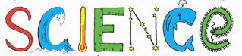  We know that effective Science learning occurs in Leigh St John’s C.E Primary when:
Children  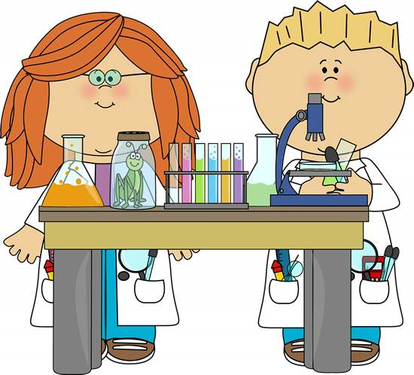 | - Are engaged and asking questions  - Find lesson enjoyable and intriguing  - Are given a genuine purpose to investigate and explore  - Demonstrate enthusiasm and a real drive to find things out for themselves or research  - Understand new concepts or apply existing knowledge/understanding in their learning  - Can’t wait for the next lesson
Science | - Children are given the opportunity to work practically and discover things for themselves  - After school science clubs, visitors and science trips ignite children’s passion for the subject  - Working outside the classroom makes learning meaningful and memorable  - Cross – curricular learning is purposeful and interactive  - Learners feel inspired, driven and motivated to succeed  - Learners envisage STEM in their future career aspirations
Adults | - Meet the National Curriculum Objectives  - Generate a buzz around Science (through visitors, trips, clubs, lessons and Science Week)  - Challenge children and generate deep thinking through open – ended questions  - Allow children to record their observations in different ways (include use of ICT/ Tapestry)  - Have good scientific knowledge and understanding and so they are confident to teach it  - Provide opportunities for children to use the 5 types of scientific enquiry.

